**TIMING CONSTRUCTION**

[**https://www.interviewbit.com/networking-interview-questions/**](https://www.interviewbit.com/networking-interview-questions/)

**1. What is an IPv4 address? What are the different classes of IPv4?**

An IP address is a 32-bit dynamic address of a node in the network. An IPv4 address has 4 octets of 8-bit each with each number with a value up to 255.

IPv4 classes are differentiated based on the number of hosts it supports on the network. There are five types of IPv4 classes and are based on the first octet of IP addresses which are classified as Class A, B, C, D, or E.

| **IPv4 Class** | **IPv4 Start Address** | **IPv4 End Address** | **Usage** |
| --- | --- | --- | --- |
| A | 0.0.0.0 | 127.255.255.255 | Used for Large Network |
| B | 128.0.0.0 | 191.255.255.255 | Used for Medium Size Network |
| C | 192.0.0.0 | 223.255.255.255 | Used for Local Area Network |
| D | 224.0.0.0 | 239.255.255.255 | Reserved for Multicasting |
| E | 240.0.0.0 | 255.255.255.254 | Study and R&D |

**2. Explain different types of networks.**

Below are few types of networks:

| **Type** | **Description** |
| --- | --- |
| PAN (Personal Area Network) | Let devices connect and communicate over the range of a person. E.g. connecting Bluetooth devices. |
| LAN (Local Area Network) | It is a privately owned network that operates within and nearby a single building like a home, office, or factory |
| MAN (Metropolitan Area Network) | It connects and covers the whole city. E.g. TV Cable connection over the city |
| WAN (Wide Area Network) | It spans a large geographical area, often a country or continent. The Internet is the largest WAN |
| GAN (Global Area Network) | It is also known as the Internet which connects the globe using satellites. The Internet is also called the Network of WANs. |

**3. Explain LAN (Local Area Network)**

LANs are widely used to connect computers/laptops and consumer electronics which enables them to share resources (e.g., printers, fax machines) and exchange information. When LANs are used by companies or organizations, they are called **enterprise networks**. There are two different types of LAN networks i.e. wireless LAN (no wires involved achieved using Wi-Fi) and wired LAN (achieved using LAN cable). Wireless LANs are very popular these days for places where installing wire is difficult. The below diagrams explain both wireless and wired LAN.

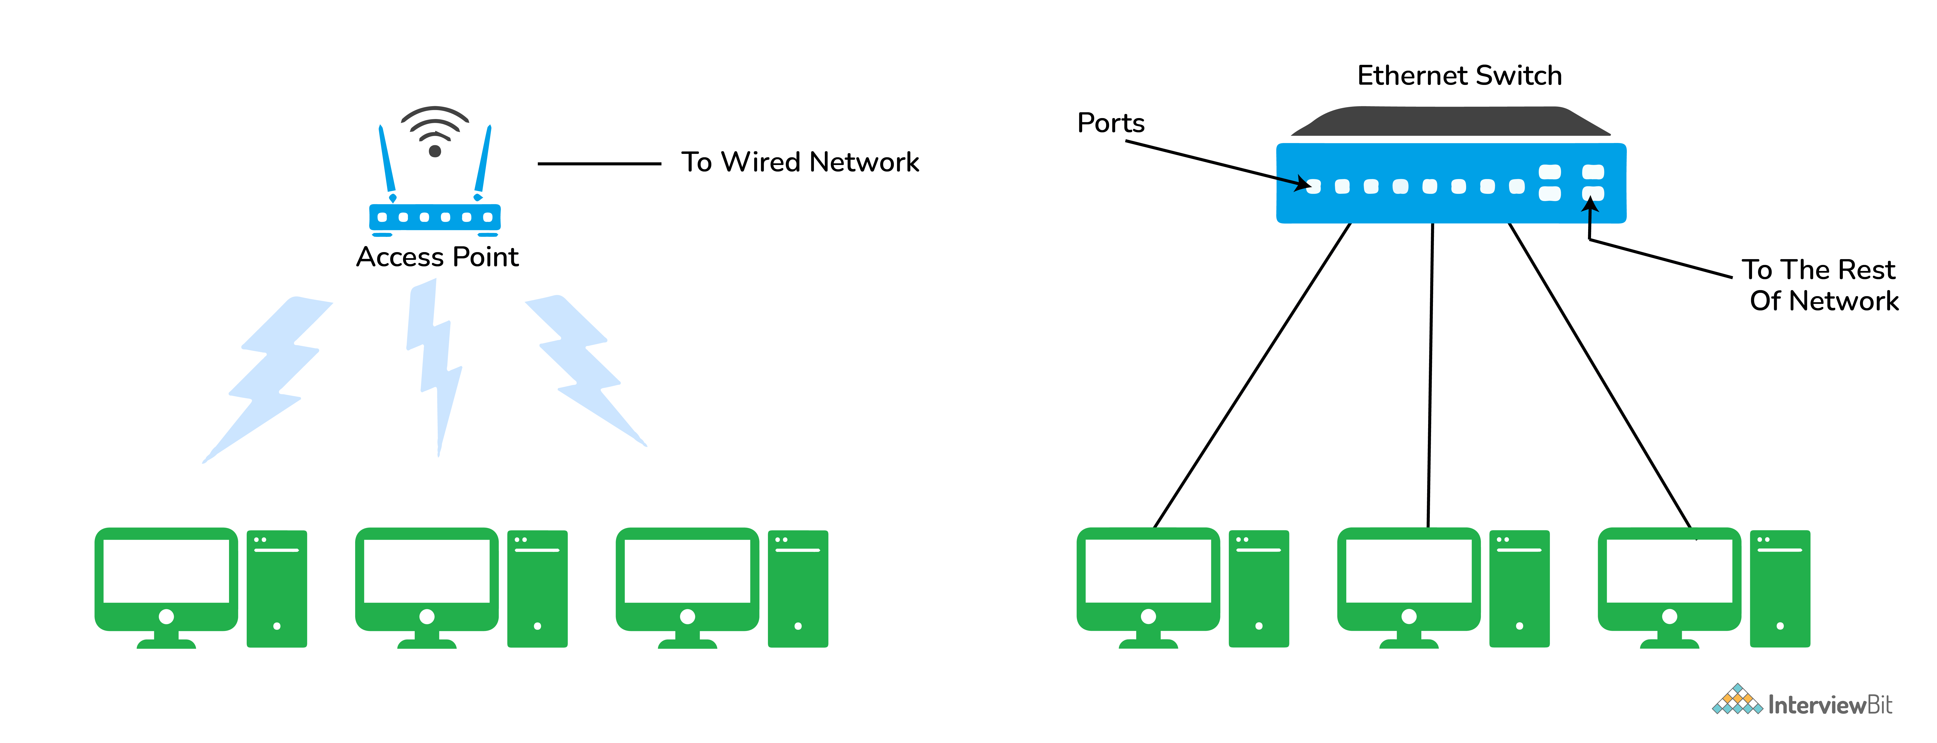LAN (Local Area Network)

**4. Tell me something about VPN (Virtual Private Network)**

VPN or the Virtual Private Network is a private WAN (Wide Area Network) built on the internet. It allows the creation of a secured tunnel (protected network) between different networks using the internet (public network). By using the VPN, a client can connect to the organization’s network remotely. The below diagram shows an organizational WAN network over Australia created using VPN:

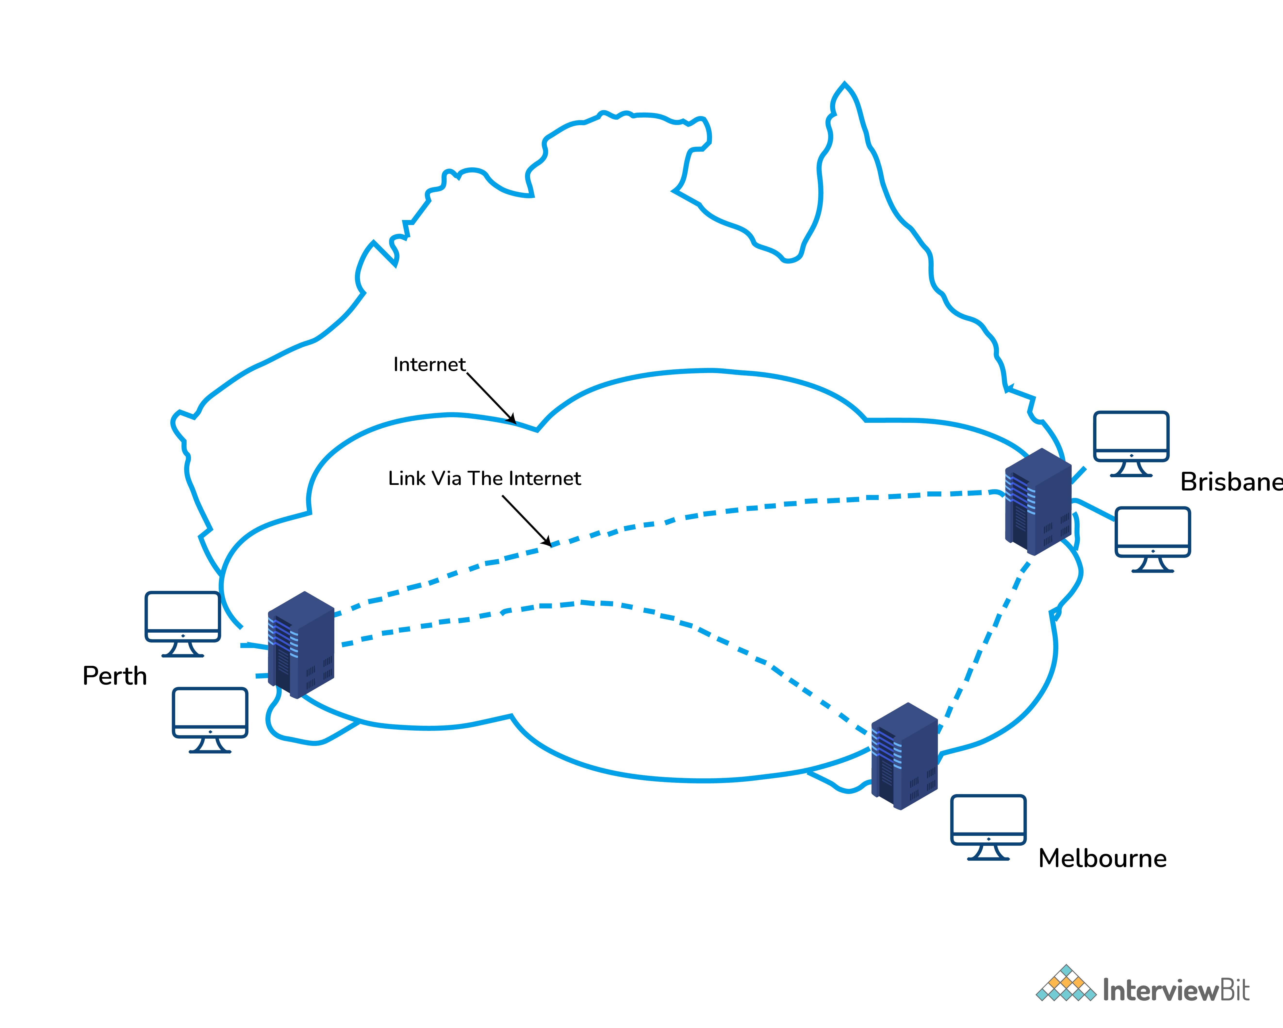VPN (Virtual Private Network)

**5. What are the advantages of using a VPN?**

Below are few advantages of using VPN:

* VPN is used to connect offices in different geographical locations remotely and is cheaper when compared to WAN connections.
* VPN is used for secure transactions and confidential data transfer between multiple offices located in different geographical locations.
* VPN keeps an organization’s information secured against any potential threats or intrusions by using virtualization.
* VPN encrypts the internet traffic and disguises the online identity.